**CODE DEPLOY CODE PIPELINE :**

1. **Create iam user with cli interface**
2. **Create role with admin access**
3. **Create role for code deploy**

**Create server for development and production server :**

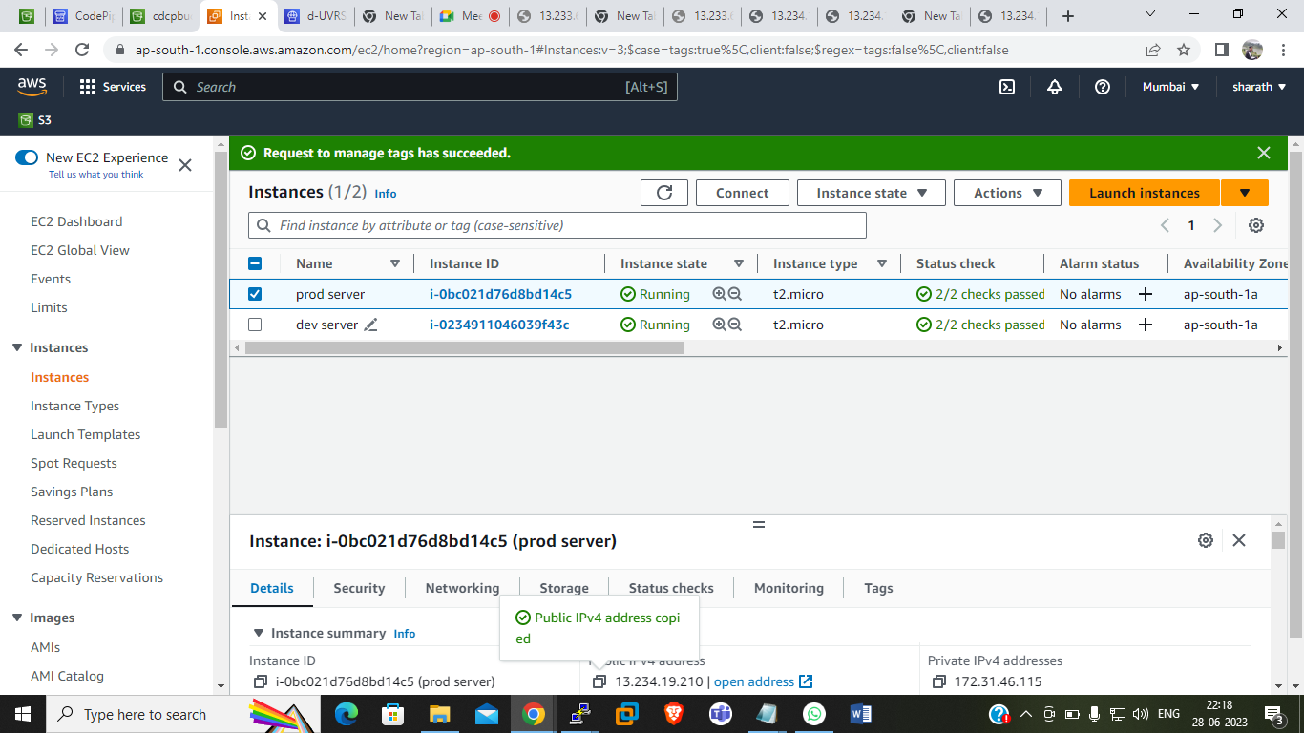

**Open and deploy the dev.server in putty with the following steps :**

Sample HTML code.

-----------------

<html>

<h2> Sample App Version 1 </h2>

</html>

Create appspec.yml

------------------

version: 0.0

os: linux

files:

- source: /index.html

destination: /var/www/html/

hooks:

BeforeInstall:

- location: scripts/httpd_install.sh

timeout: 300

runas: root

- location: scripts/httpd_start.sh

timeout: 300

runas: root

ApplicationStop:

- location: scripts/httpd_stop.sh

timeout: 300

runas: root

----------***__---------**___-------

mkdir scripts

cd scripts

vi httpd_install.sh

vi httpd_start.sh

vi httpd_stop.sh

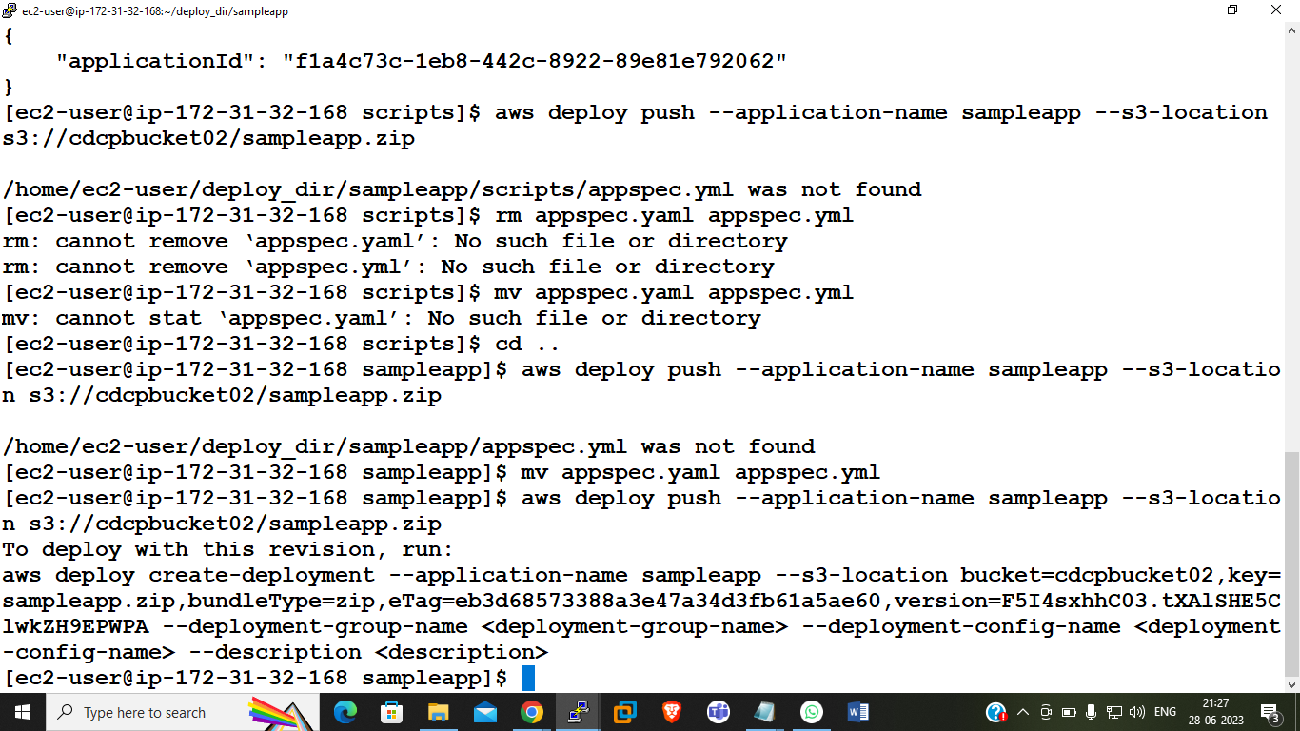

----------------------------------

#!/bin/bash

yum install -y httpd

#!/bin/bash

systemctl start httpd

systemctl enable httpd

#!/bin/bash

systemctl stop httpd

systemctl disable httpd

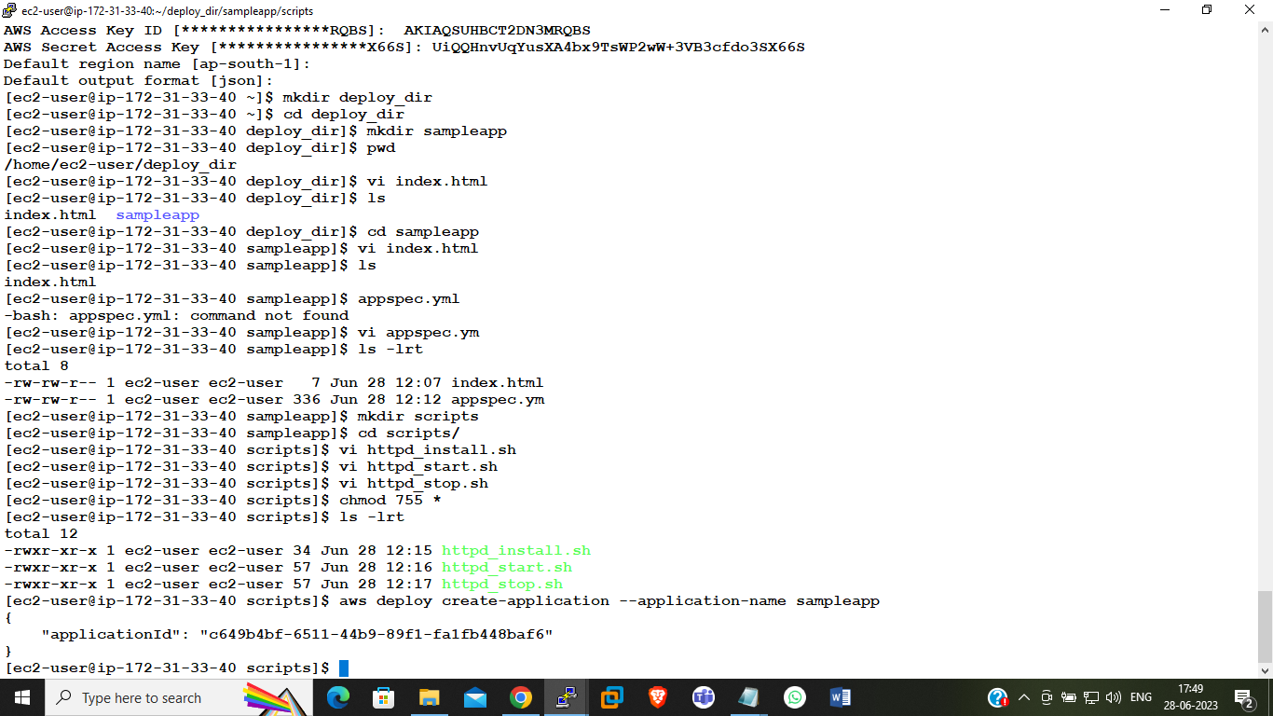

: create bucket with public access and push the codes in s3 bucket in zip file format :

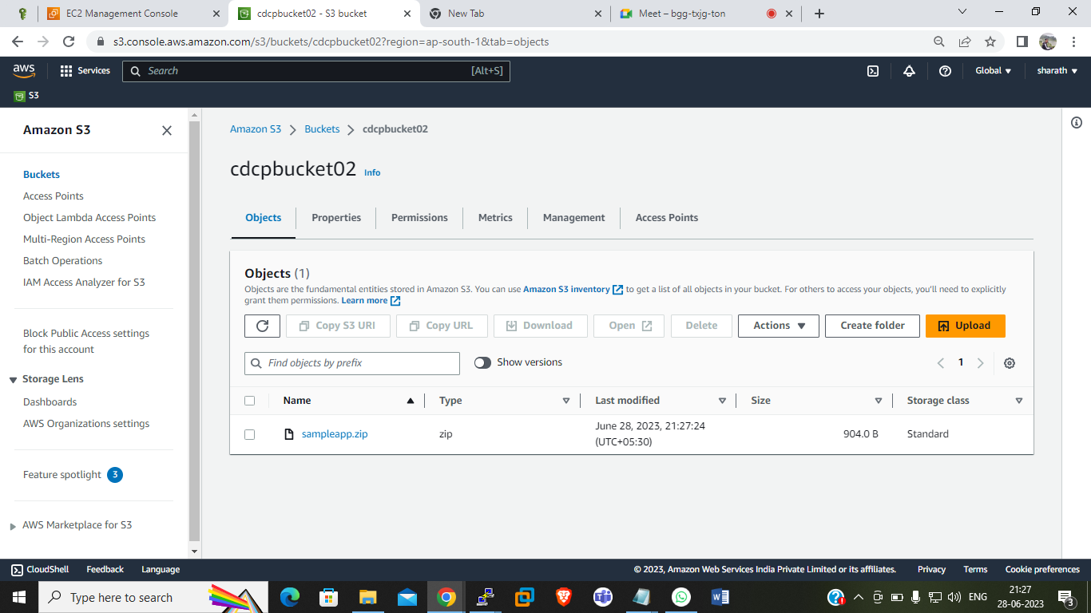

create deployment group :

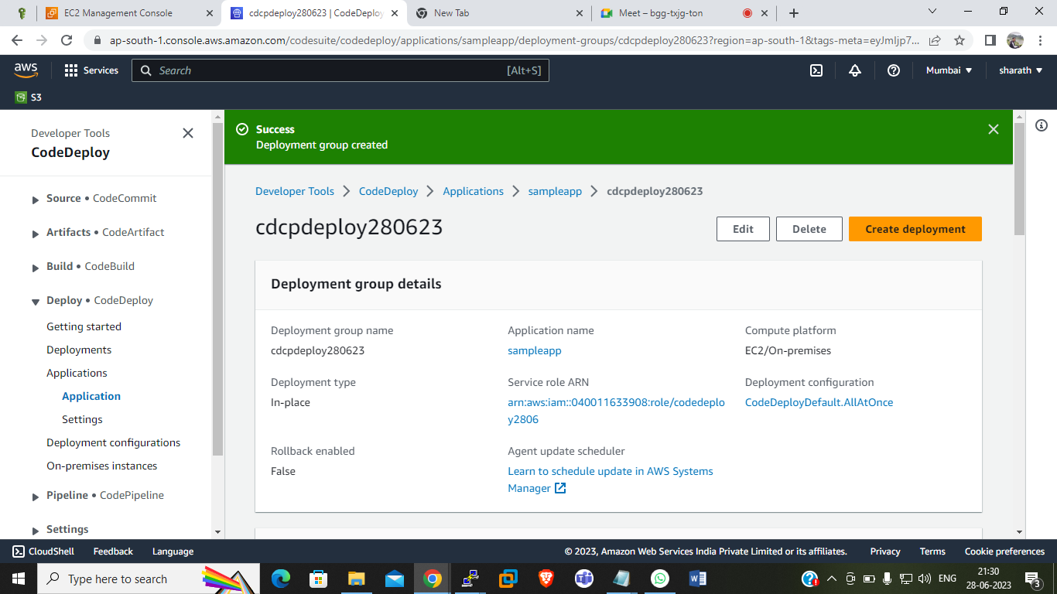

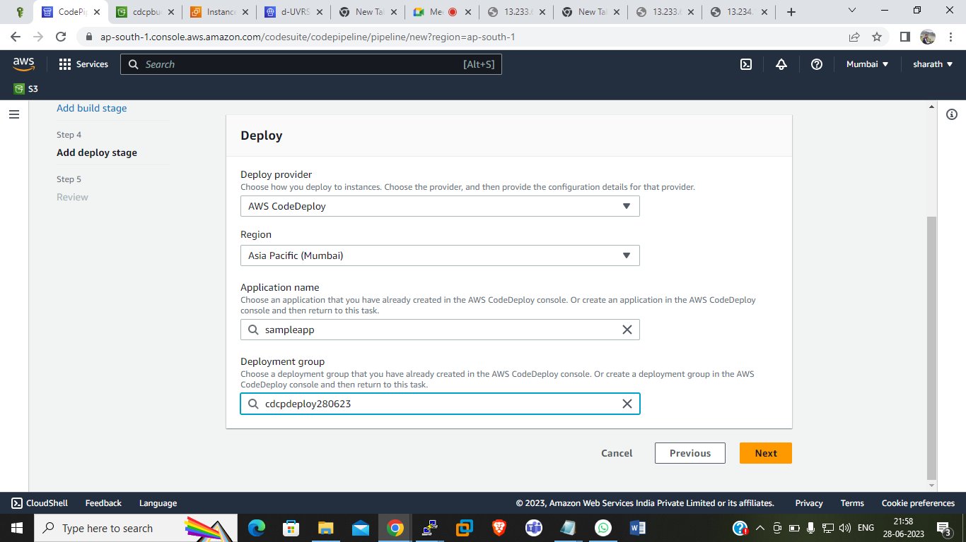

login production server :

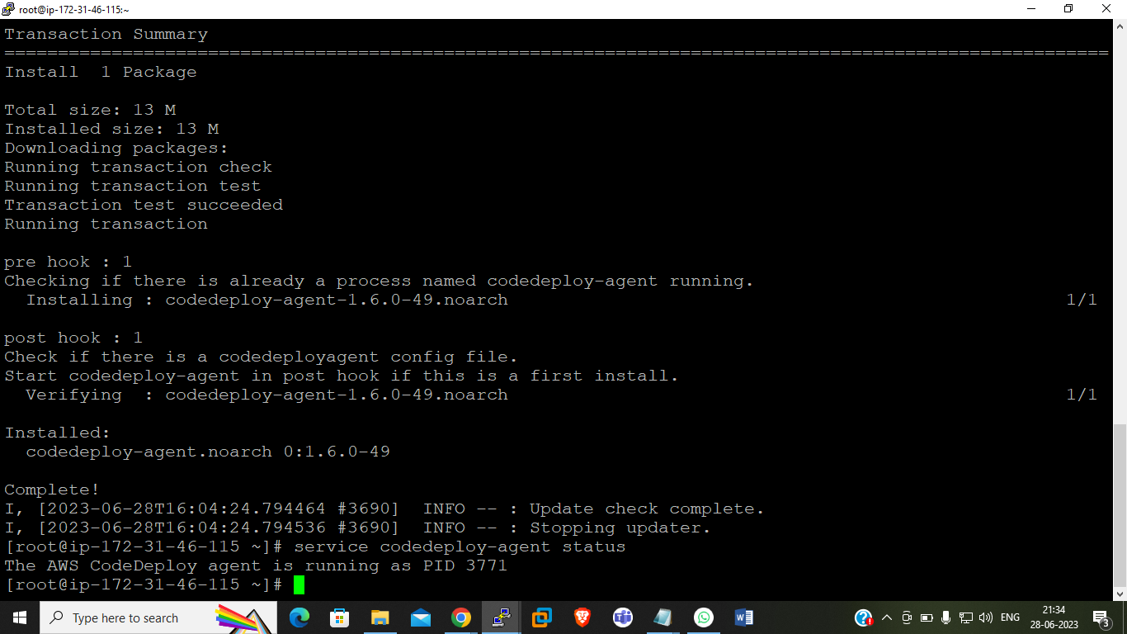

codedeploy Results

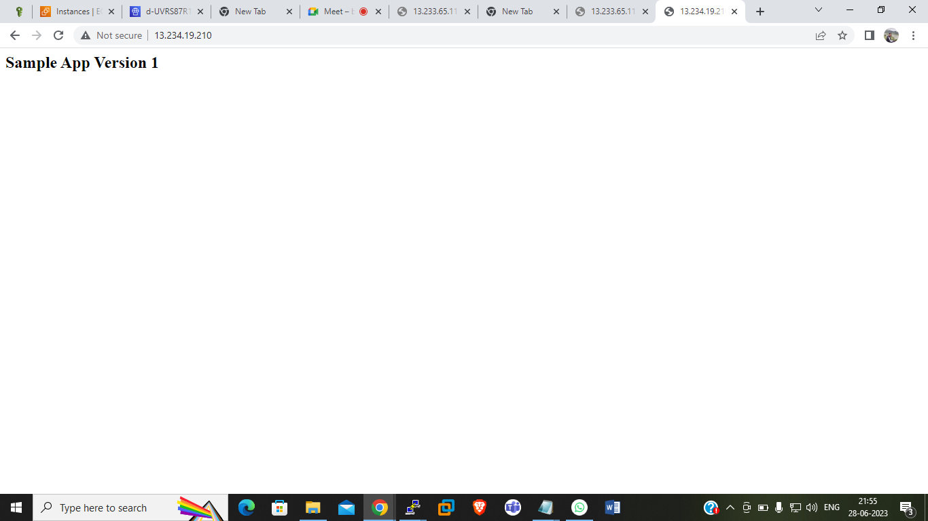

Create cloudpipeline :

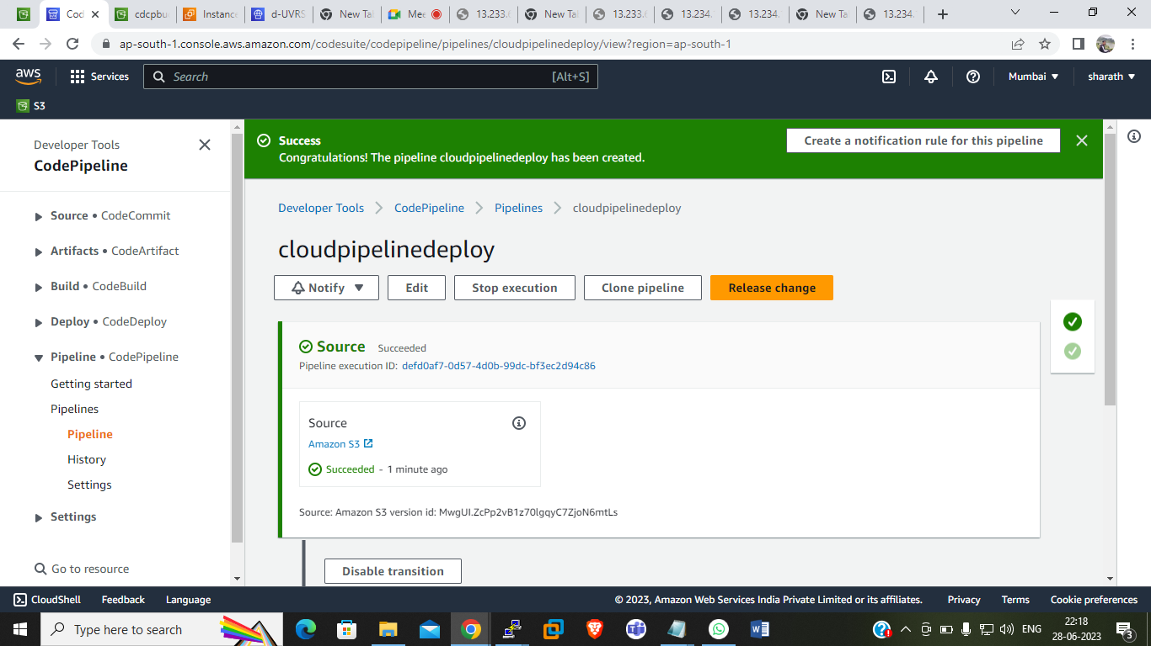

After enable versioning :

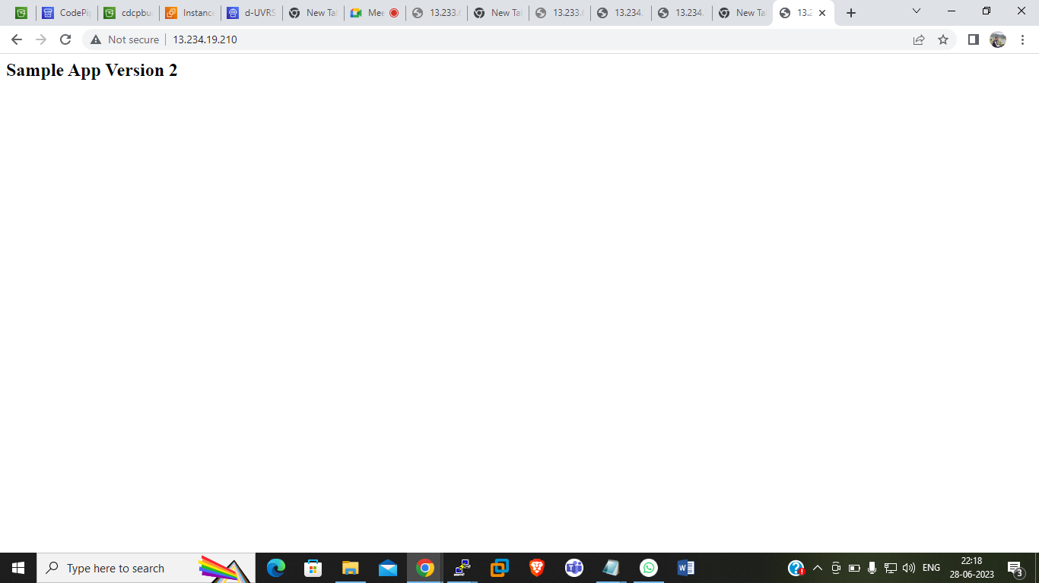

With the help of cloudwatch, notification will be sent to email if deployment or any update occurs.